
QDI External Entity Onboarding – Integration Guide for Remote Signing Service (RSS)

Issue | : | 3.0
Issue date | : | 25 March 2025
Status | : | Draft

Amendment history
Date | Issue | Status | Changes | Author
03/11/2022 | 1.0 | Draft | Issue draft version | Identity Team
26/10/2023 | 2.0 | Draft | Issue draft version | Muhammad Irfan
10/01/2024 | 2.1 | Draft | Formatting and restructuring only | Rizwan Akbar
12/02/2024 | 2.1 | Draft | Updated fig. in eSeal Signing | Muhammad Irfan
25/03/2025 | 3.0 | Draft | Whole document is revised | Muhammad Irfan
20/05/2025 | 3.0 |  | Added a note under 4.1.1 | Muhammad Irfan
16/06/2025 | 3.0 |  | Updated section 3. Firewall Rules | Muhammad Irfan

Table of Contents
1. Introduction 5
1.1. Background 5
1.2. Audience 5
1.3. Glossary 5
2. Remote Signing Service (RSS) Overview 7
2.1. What is a Digital Signature? 7
2.2. User Signature 7
2.3. eSeal Signature 7
2.4. Signature Verification 7
2.5. Why do we need Digital Signatures? 7
2.6. MOI RSSP Supported Digital Signature Standards 8
2.7. MOI RSSP Service Offerings 8
2.7.1. User Signing via QDI Mobile Application 8
2.7.2. eSeal Signing 10
2.7.3. Signature Verification 11
3. Firewall Rules 13
3.1. Staging 13
3.2. Production 14
4. Integration Sample Code 15
4.1. User Signing 15
4.1.1. Validate QID for User Signing 15
4.1.2. Share Document for Signing 16
4.2. eSeal Signing 17
4.3. Signature Verification 18
5. QDI SigningHub (Document Signing Workflow) 20
5.1. SigningHub Terminologies 20
5.1.1. Packages 20
5.1.2. Users 20
5.1.3. Groups 21
5.1.4. Signing Workflow 22
5.1.5. Work Flow Template 22
5.1.6. Creating Workflow Templates (API Not Available) 23
5.1.7. Adding Library Document (API Not Available) 24
5.2. Document Sharing for Signing (User +e Seal) 25
5.2.1. Authenticate/Logout 26
5.2.2. Add Package 27
5.2.3. Add Document from Library 27
5.2.4. Update Workflow User/ Add Users to Workflow 27
5.2.5. Share Document Package 27
5.2.6. Get Workflow Details 27
5.2.7. Download Document 27
5.2.8. Delete Package 27
5.3. Document Signing (eSeal) 28
5.4. Webhooks 28
6. 2nd Factor Authentication using QDI 30
7. Remote Signing Service (RSS) Credentials 32
7.1. Staging 32
7.2. Production 32
8. Activity Logs 33
9. Appendix 34
9.1. Case Escalation 34

Introduction

Background
This document describes the requirement for an external entity to integrate its business application with Ministry of Interior – Remote Signing Service (MOI RSS) to digitally signing the documents.
MOI is operating the following Certificate Authorities (CAs). MOI TSP can provide the required certificates to sign the documents using the Remote Signing Service (RSS) and eSeal signing. The following is the MOI TSP’s CA hierarchy:
- MOI QA National Root CA
  - Corporate and Individual CA
  - Timestamping CA
  - Infrastructure CA
The QDI (Qatar Digital Identity) mobile application is used to complete the digital signing transactions such as:
- Certificate lifecycle management (create, renew)
- Signing electronic document and/or transactions
- Authenticating end users for e-Services portal access

Audience
The document audience are technical personnel with basic understanding of PKI, Digital Signatures and good Java/.NET development skills.

Glossary
The following terms and acronyms are used in this document:
Acronym | Term
MOI | Ministry of Interior
CA | Certification Authority
QPKI | Qatar PKI
ID | Identity
VSC | Virtual Smart Card
OCSP | Online Certificate Status Protocol
PIN | Personal Identification Number
PKI | Public Key Infrastructure
QDI | Qatar Digital Identity
QID | Qatar Identification Document
TS | Timestamp Service
SP | Service Provider
RSS | Remote Signing Service
RSSP | Remote Signing Service Provider
SSA | Signature Signing Application

Remote Signing Service (RSS) Overview
A Remote Signing Service Provider (RSSP) typically operates an HSM (or functionally equivalent multi-user secure device) and an Authentication Service. It manages the users and provides a signing service that can be accessed over the internet by means of the API described in this document.
A Remote Signing Service (RSS) typically manages signing keys and certificates that are created before the signing operations take place. A common scenario is also when the signing key and the certificate are created in the course of a signing operation.
MOI is the Remote Signing Service Provider (RSSP) in the State of Qatar. This RSSP allows the entity users to create the signing keys using the QDI mobile app and use their business application to create the digital signatures using the credentials created using QDI app but stored on the RSSP server securely.

What is a Digital Signature?
A digital signature is a mathematical scheme for verifying the authenticity of digital messages or documents. A valid digital signature, where the prerequisites are satisfied, gives the recipient a very high confidence that the message was created by a known sender, and that the message was not altered in the transit.

User Signature
If a digital signature is created by a natural person key (e.g. a Qatari resident or a citizen), called a user signature.

eSeal Signature
If a digital signature is created by a legal person (e.g. a business or a ministry), called an eSeal signature e.g. Police Clearance Certificate issued & signed by MOI

Signature Verification
When you receive a signed document, you may want to validate its signature to verify the signer and the signed content. Signature validity is determined by checking the authenticity of the signature’s digital ID certificate status and document integrity.
The MOI Verification Service is a server-side solution for both verifying digitally signed documents and validating certificates to check the certificate expiry, revocation status, signed by a trusted CA, etc.).

Why do we need Digital Signatures?
The digital signatures provide several advantages over the conventional wet ink/paper signatures and some of the benefits are outlined below:
Authenticity – it refers that the document has been signed by a known person where a person could be a natural person (human) or a legal person (a business)
Integrity – it refers that the document has not been altered since the digital signature is created. In case, the document has been altered, it can be detected by the digital signature verification service since the digital signature has been applied on it.
Non-repudiation – it is a legal term, which provides the assurance that someone cannot deny the validity of something especially in the court of law. Non-repudiation refers to the ability to ensure that a party must accept the authenticity of their signature on a contract. Otherwise, the signer must face the legal consequences if he falsely denies the contract was not signed using his signing key.

MOI RSSP Supported Digital Signature Standards
MOI Remote Signing Service Provider (RSSP) supports the following digital signature standards:
- PDF and PAdES
- XML DSig and XAdES
- CMS and CAdES
- PKCS#1

MOI RSSP Service Offerings
MOI RSSP supports the following signing scenarios:
- User Signing via QDI Mobile Application
- eSeal Signing
- Signature Verification

User Signing via QDI Mobile Application
In authorized signing, the signing keys are generated and stored in a secure environment. The signing key can only be used with the user authorization. The user uses the QDI app to connect the Authorization Service to authorize the signing key. The MOI RSSP complies with EU Regulation No 910/2014 (eIDAS) which addresses the creation of remote electronic signatures using electronic signature creation data that is managed remotely by a third-party trust service provider (entity’s business application) working on behalf of the signee.
To be considered compliant with above mentioned regulation, the electronic signature must meet three requirements:
- The signature must be uniquely identified and linked to its signatory.
- The data that is used to create that signature must be under the signatory’s sole control and no one else.
- Tamper-proof protections must be in place to identify if tampering has taken place with the data that accompanies the signature since the signing of the message.
The entity follows the below steps for the remote authorized signing:
- The entity integrates its business application with the MOI RSS using the sample code provided with this document.
- The entity user installs the QDI mobile app from the Google Play Store or Apple Store where the user:
  - Creates an account on the QDI app.
  - Login to the QDI app.
  - Creates a Digital Signature Key from the QDI app.
- The entity user initiates the signature creation from the business application.
- The entity user logs into the QDI app, go to Digital Signature > Pending Documents
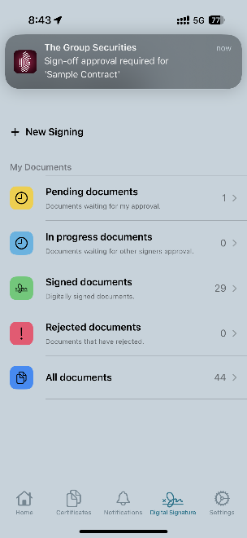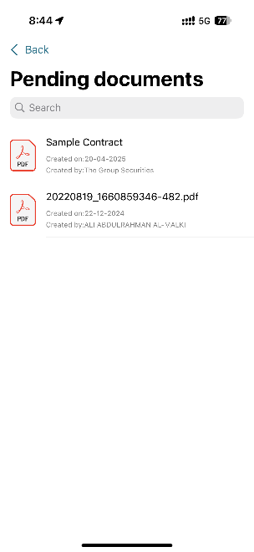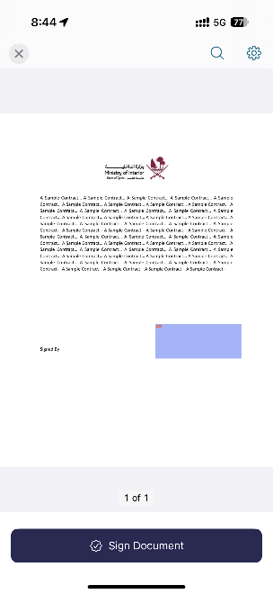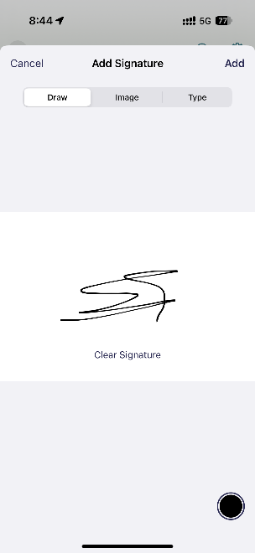
- Tap on a pending document to open and view it.
- Tap on highlighted signature field to sign it.
- A dialog will appear to draw user signature
- Tap on Green button/Add at bottom/top right
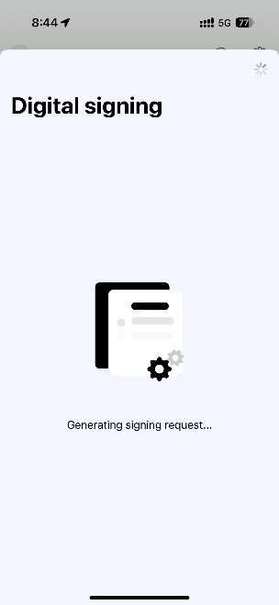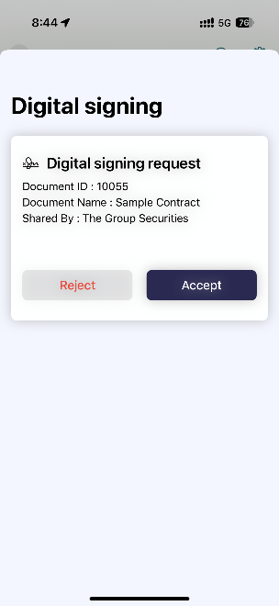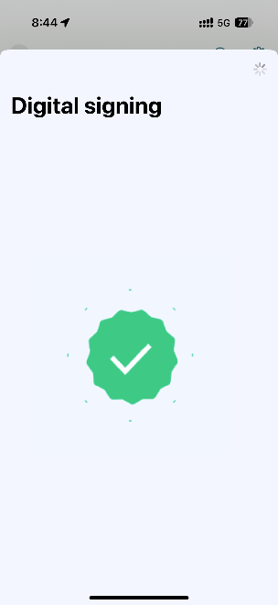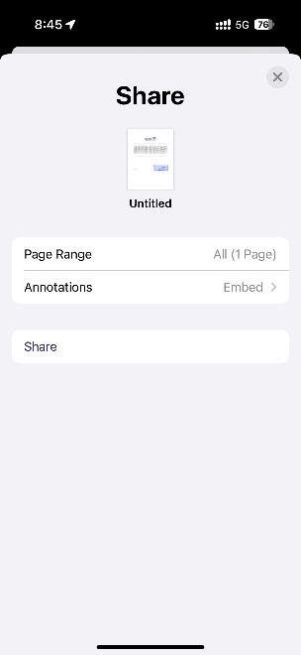
- An authorization dialog will appear, accept to complete the signing
- User can see the document at Digital Signature > Signed Documents
- User can download and share the document.
- The business application can download the signed document from MOI Signing Service.
For integration details see User Signing

eSeal Signing
An Electronic Seal, also known as an eSeal, is an electronic signature that is associated with a legal entity (business or ministry) and can be used by more than one person within the legal entity. To generate an eSeal, a legal entity needs to be vetted and authenticated through a third party or through a remote identity verification process. An eSeal can be used to automatically sign large volumes of documents (bulk signing), such as invoices or educational transcripts, through an accredited digital signing solution. Electronic Seals authenticate the identity of the entity and the integrity of the document.
An electronic seal is technically same as a digital signature. The difference is that a digital signature can be associated to both a natural person and legal person, whereas a seal is associated only to a legal person/entity. The signing key must be under the sole control of the signatory and the seal key must be under control of the process creating the seal.
The entity should follow the below steps for the eSeal signing:
- The entity integrates its business application with the MOI RSS using the sample code provided with this document.
- The entity user initiates the signature from the business application. Note that, no explicit authorization is required to use the eSeal key.
- After the successful signing (eSeal), the document is updated in the business application.

Signature Verification
Verification service enables organizations to check document and data signatures at the server and extract a variety of valuable information from the signatures. Applications can be given data about who has signed and if any data or signatures cannot be trusted then this can be flagged immediately. The Verification Service offers a very effective high-trust solution for verifying digitally signed documents and data. It can also validate end-user certificates and the entire certificate chain, including checking the certificate expiry, revocation, signed by a trusted CA etc.). The following are the high-level steps of the signature verification process:
- An end-user submitted a signed document such as a signed purchase order to a business web-application. Before processing this, the application needs to check the signature on the document is trustworthy.
- It forwards the document to the MOI RSS verification service for its verification analysis and verdict.
- The MOI RSS Verification Service performs a sequence of verification checks to ensure that the signature has been generated correctly, that the signer’s certificate was issued by a recognized and trusted CA, signer certificate is valid, the key usage, policy OIDs and other trust criteria are met.
- As part of this signature verification process, MOI RSS Verification service also requests certificate status information from the relevant certificate status provider, either in the form of real-time OCSP calls or by checking the relevant CA’s CRL.
- MOI RSS Verification Service provides a signature verification response with the overall status of each signature in the document, i.e. “trusted”, “not trusted” or “indeterminate”.
- MOI RSS Verification Service can also be asked to return a range of details from the signer’s certificate and other items if these are specified in the verification request from the business application.

Firewall Rules
The government entity is required to submit a Change Request to the MCIT to open the access from the external entity to the MOI services to enable the communication between ADSS Gateway Server and MOI RSS.

Staging
Below access is required between external entity and MOI via Government Network:
 | MOI - GN
# | IP or URL | Port | Comments
 | 10.36.10.73 | 443 | QDE Manager WS Service:  - QID validity and applicability for Signing  - 2nd Factor Authorization  https://testqdign.moi.gov.qa/QDE_EJB_HTTPRouter/QDEManagerWSService/QDEManagerWSService.wsdl
 | 10.36.10.55 | 443 | eSeal Gateway  https://stgqdisigngw.moi.gov.qa/adss/signing/hdsi  Verification Gateway  https://stgqdisigngw.moi.gov.qa/adss/verification/hsvi
 | 10.36.10.69 | 443 | User Signing  https://stgsignapi.moi.gov.qa (Web Interface)  https://stgsignmanuals.moi.gov.qa (API)  https://stgsign.moi.gov.qa (API Documentation)  SigningHub Webhook Listener Server at Client and MOI User Signing Server. Client need to provide a GN IP in their environment on which a server is listening webhooks from MOI User Signing Server
Table ‎3-1
Additionally, you are required to add the following entries in the hosts file on the Application Server machine:
10.36.10.55 stgqdisigngw.moi.gov.qa
10.36.10.69 stgsign.moi.gov.qa
10.36.10.69 stgsignapi.moi.gov.qa
10.36.10.69 stgsignmanuals.moi.gov.qa
10.36.10.73 testqdign.moi.gov.qa

Table ‎3-2

Production
Below access is required between external entity and MOI via Government Network:
 | MOI - GN |  | Comments
# | IP or URL | Port | URL
- 1 | 10.36.10.72 | 443 | QDE Manager WS Service:  - QID validity and applicability for Signing  - 2nd Factor Authorization  https://qdign.moi.gov.qa/QDE_EJB_HTTPRouter/QDEManagerWSService/QDEManagerWSService.wsdl
- 2 | 10.36.10.34 | 443 | eSeal Gateway  http://qdisigngw.moi.gov.qa/adss/signing/hdsi  Verification Gateway  http://qdisigngw.moi.gov.qa/adss/verification/hsvi
 | 10.36.10.39 | 443 | User Signing  https://sign.moi.gov.qa  https://signapi.moi.gov.qa  SigningHub Webhook Listener Server at Client and MOI User Signing Server. Client need to provide a GN IP in their environment on which a server is listening webhooks from MOI User Signing Server
Table ‎3-3
Additionally, you are required to add the following entries in the hosts file on the Application Server machine:
10.36.10.34 qdisigngw.moi.gov.qa
10.36.10.39 sign.moi.gov.qa
10.36.10.39 signapi.moi.gov.qa
10.36.10.72 qdign.moi.gov.qa

Table ‎3-4

Client Need to fill a CR form provided by MOI in order to connect to MOI via GN

Integration Sample Code

User Signing
User Signing requires the target user to be registered at QDI Mobile Application and must have a valid Digital Signing Certificate Issued by MOI. It is nice to check if the target user has a signing certificate or not before sharing a document for signing with him/her. Therefore, Business Application is required to make following to steps in order to share a PDF document for User Signing:

Validate QID for User Signing
Step one can be done by calling validateQID method of QDE using the following integration guide:
Sample XML requests/responses are bundled along with this document
Note:
Checking whether the user already has a QDI (Digital Signing Certificate) is optional. If the user has not yet registered with QDI for digital signing, the client may still proceed to share the document. Once the user completes QDI registration, the document will appear in their list of pending documents.
However, if this preliminary check (Step 1) is skipped, it becomes the client’s responsibility to ensure that the correct QID is used during document sharing. The system does not validate the existence or correctness of the QID and will not return an error for a non-existent or invalid QID. It assumes all provided QIDs belong to current or future QDI users.

Share Document for Signing
For details on this see QDI SigningHub (Document Signing Workflow)
Below is an expected output after user signing:
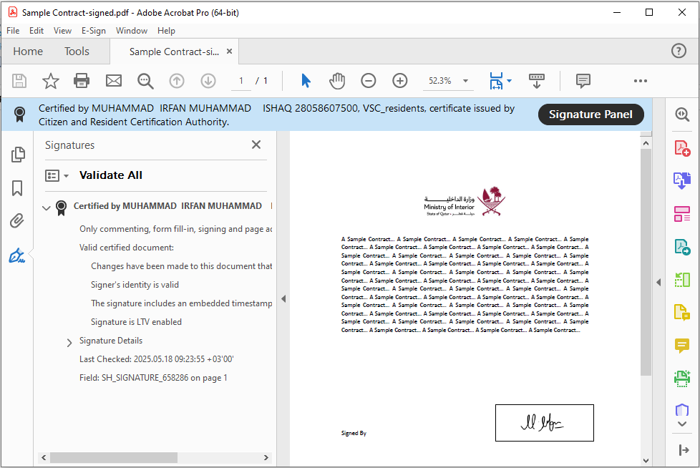

eSeal Signing
Integration sample code for eSeal is available in below sample:
- JAVA: src/com/ascertia/adss/client/samples/signing/MoiEseal
- .NET: src/Com/Ascertia/ADSS/Client/API/Samples/Signing/MoiEseal
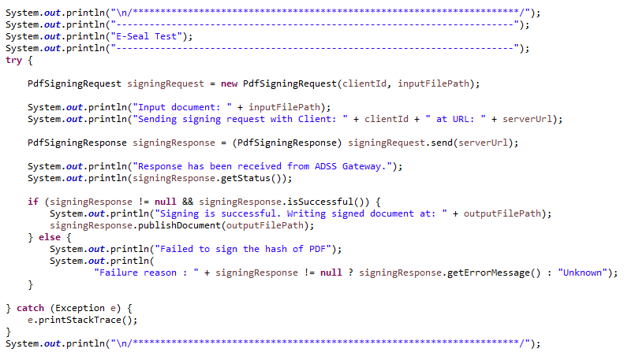
Complete class is attached to this document

Signature Verification
Integration sample code for PDF Signature Verification is available in below sample:
- JAVA: src/com/ascertia/adss/client/samples/verification/MoiVerifyPdfLocal
- .NET: src/Com/Ascertia/ADSS/Client/Samples/Verification/MoiVerifyPdfLocal
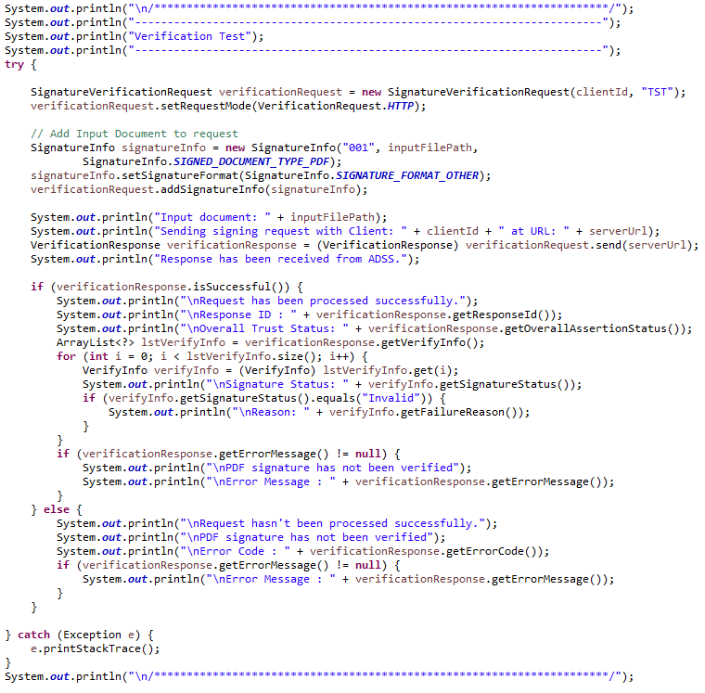
Complete class is attached to this document

QDI SigningHub (Document Signing Workflow)
SigningHub is a high-trust digital signing solution for paperless business transactions. It manages signing workflow.
Documents uploaded in this component are available in QDI mobile application for signing.

SigningHub Terminologies
Before jumping into document sharing for user signing in QDI, it is worth knowing to understand the high-level components involved in this process.

Packages
SigningHub relies on document packages to handle all documents, and hence is required for all document related operations. At least one package must exist before a user can add documents to SigningHub. The package concept allows you to group similar documents into one package and share this as opposed to multiple individual files. This reduces administration time and allows SigningHub to offer real life services and situations in an electronic format.
Note all document related API calls rely on the package identifier. For example, to upload a document the call is: https://api.signinghub.com/v3/packages/{package_id}/documents. Note the package_id variable required.

Users
APIs are also available for this feature. From UI we can do it in following steps
- Login to SigninHub > Enterprise Settings > Users and click to add a new user:
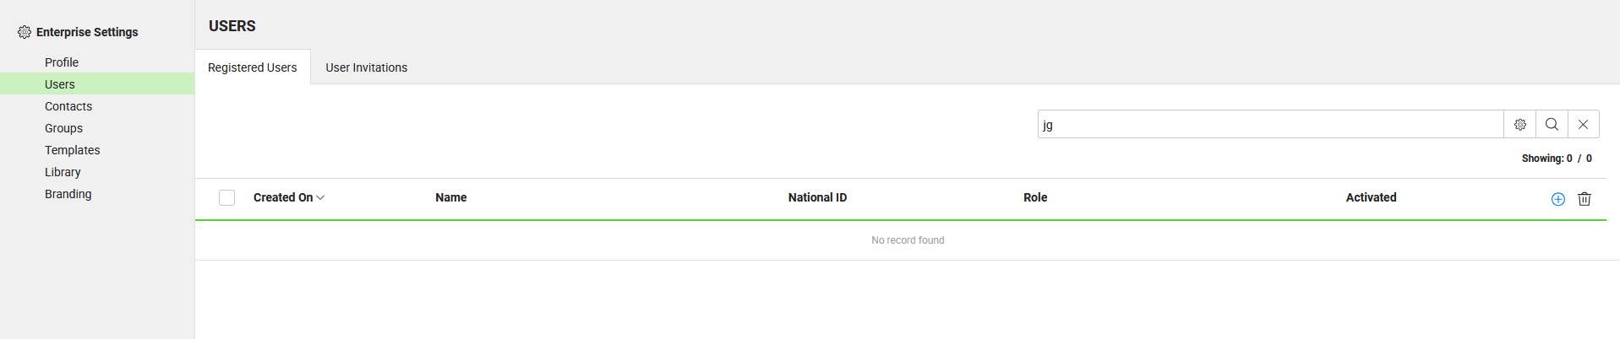
- Fill the required fields and Save
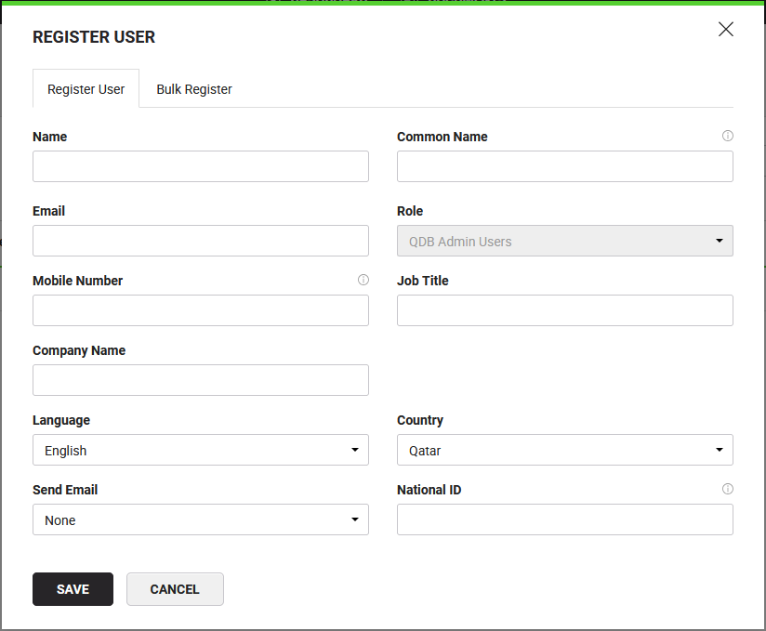

Groups
APIs are also available for this feature. From UI we can do it in following steps
- Login to SigninHub > Enterprise Settings > Groups and click to add a new Group of recipients:
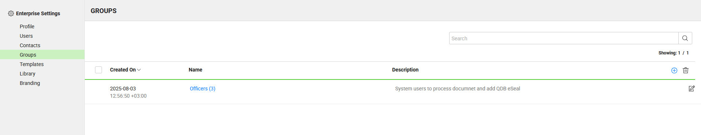
- Name the group
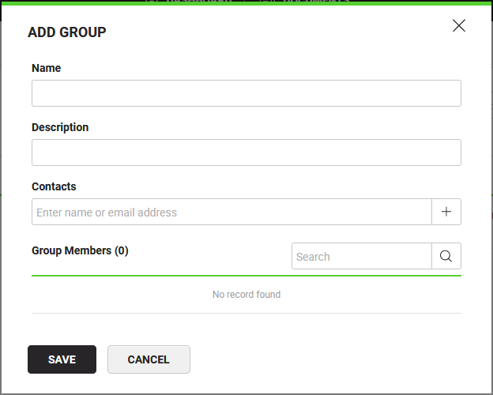
- Add contacts to the group as members and then save:
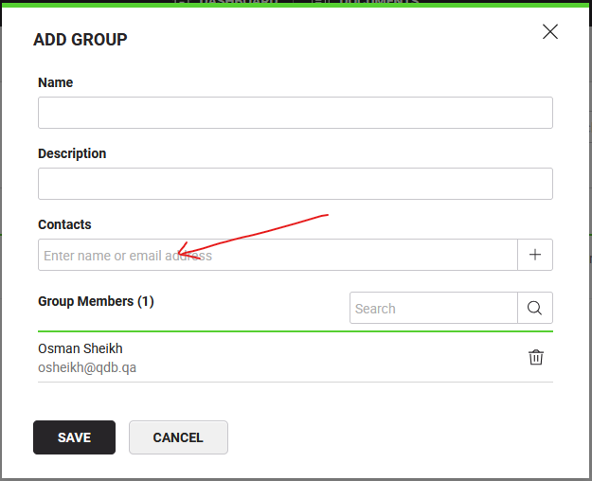

Signing Workflow
Following workflow types are available:
- SERIAL – participants can process/sign the document one after the other in a series.
- PARALLEL – any of the assigned participant can process/sign the document first.
- INDIVIDUAL – each participant has his own copy and process/sign independent of the others
- CUSTOM – mixture of above all based on requirement
Default is serial and other types are beyond the scope of this document.

Work Flow Template
A workflow template defines the location of each signature field and the user that is expected to sign the document. It also defines other document and workflow control options including PDF permissions, the ability to download or print document for example. Templates may increase efficiency, especially when a standard contract or agreement is used many times.

Creating Workflow Templates (API Not Available)
- Login to SigninHub > Enterprise Settings > Template and click to add a new template:
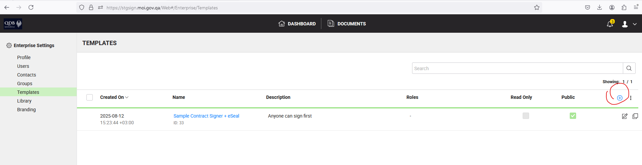
- Add/upload a sample document for which template is to be prepared:
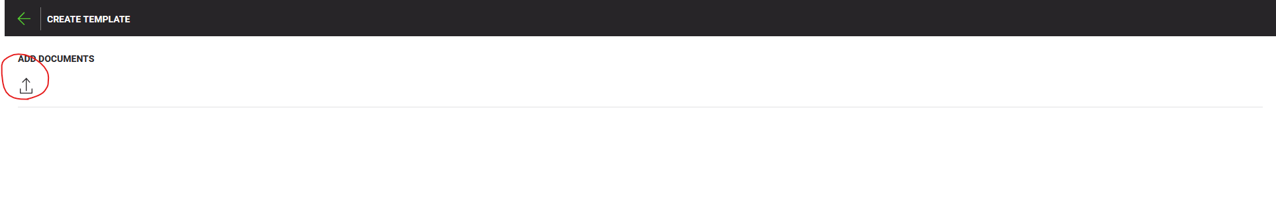
- Add recipient/placeholder/group of recipients:
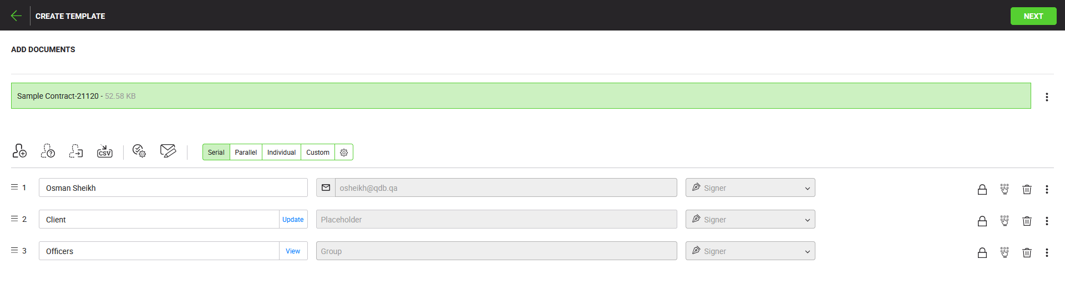
  - User Types 
    - Recipient – it includes:
      - An individual user
      - A group of user and any individual from this group can sign
    - Placeholder – it is a placeholder for signer to be filled before sharing the document for signing.
    - – out of scope of this document
  - Workflow Types 
    - Serial – Each recipient can only sign the document on his turn in a defined order.
    - Parallel – Each recipient receives the document simultaneously after sharing and can sign in any order
    - Individual & Custom – out of scope of this document
- Add Signature field(s) for each one:
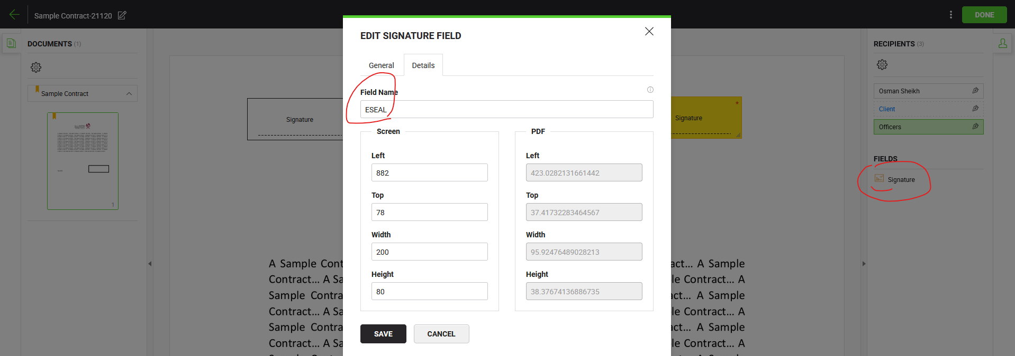
- Click Done and Save it:
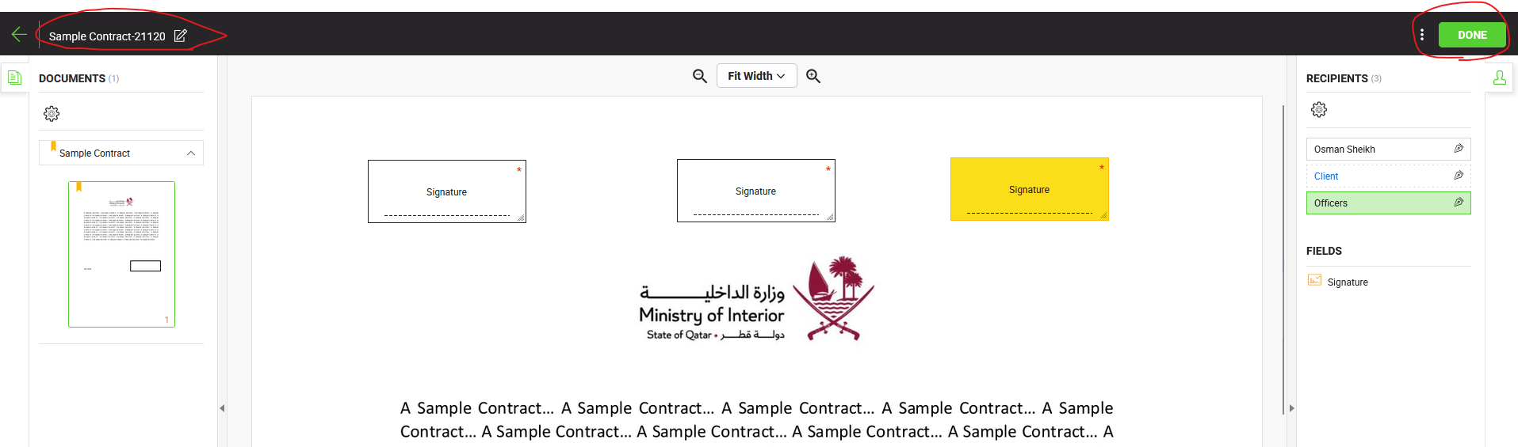
- After saving you can see the list:
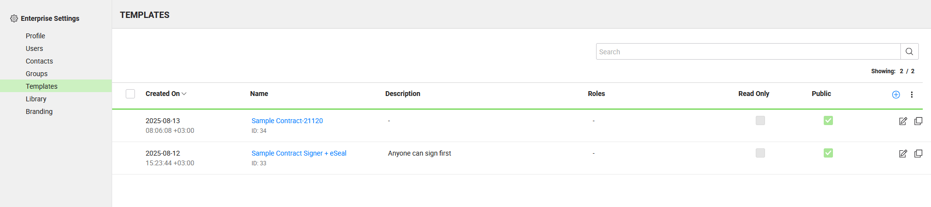
Having Templates can save workflow preparation time

Adding Library Document (API Not Available)
- Login to SigninHub > Enterprise Settings > Library and click to add a new document:
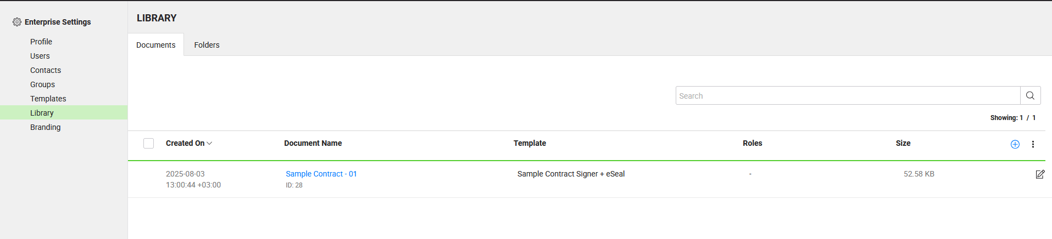
- Upload a document:
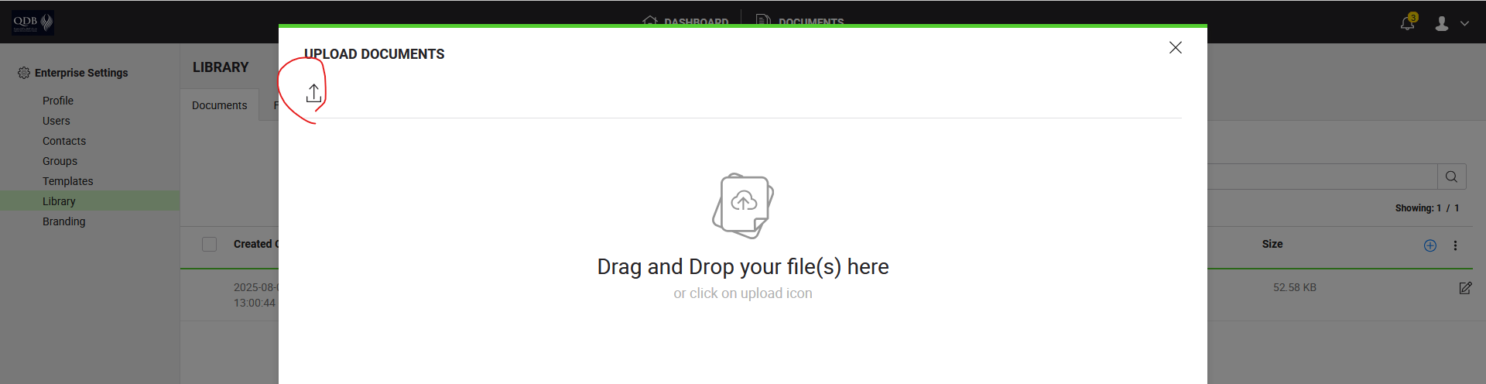
- Optionally apply a template. You can apply it while preparing a new workflow:
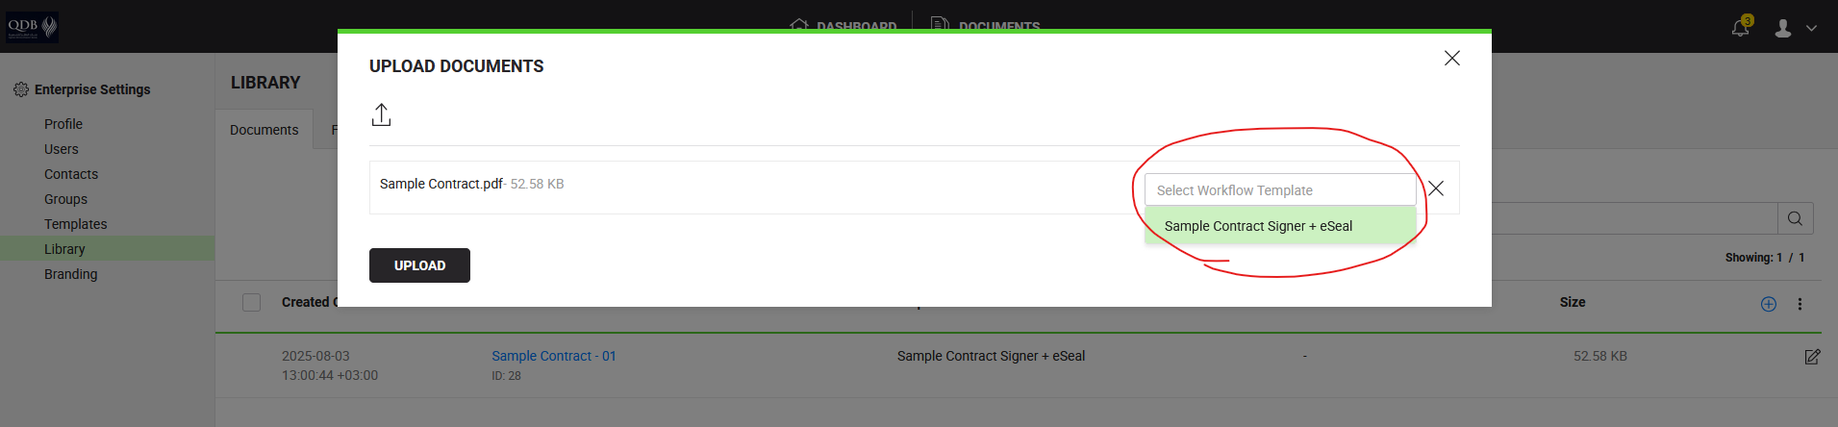
Benefit of having document in library can reduce operational time as uploading a new document is not required on runtime.

Document Sharing for Signing (User +e Seal)
Document Sharing for Digital Signing would be done by two ways:
- SigningHub UI – details is out of scop for this document.
- SigningHub APIs
A minimal set of APIs is listed in the following diagram:
Refer to attached Postman Collection & environment
[QDI Signing(User+eSeal)-STG-EE-2025-10-22.postman_environment.json]
[QDI Signing (Document Preparation+eSeal)-EE-2025-10-22.postman_collection.json]
Postman files will be provided by MOI separately.

API documentation is available at: https://stgsignmanuals.moi.gov.qa/api/
In addition to above documentation a brief description of some API is in the following lines:

Authenticate/Logout
Authentication is required to call Signing APIs. For details see link. Logout link

Add Package
Signing API manages documents to be signed as a collection of documents called a package. A package must exist before you can upload or add documents to Signing Workflow. For API contract details see link

Add Document from Library
For API contract details see link

Update Workflow User/ Add Users to Workflow
For API contract details see link
In this API, "user_email" use signer QID followed by “@moi.gov.qa” to specify a person. For example, if 28058601234 is QID, then user id is 28058601234@moi.gov.qa

Share Document Package
For API contract details see link

Get Workflow Details
A document package status in workflow details would be one of the followings:
- DRAFT
- INPROGRESS
- PENDING
- DECLINED
- APPROVED
- UPDATED
- COMPLETED
In QDI document package workflow status is COMPLETED when all the assigned users have signed the documents. Business Application now download the document and can remove, if required, from QDI.
For API contract details see link

Download Document
For API contract details see link

Delete Package
For API contract details see link
Above list contains a minimal set of APIs required by a Business Application to share a document with a QDI user for signing. Some more related APIs are in following picture:
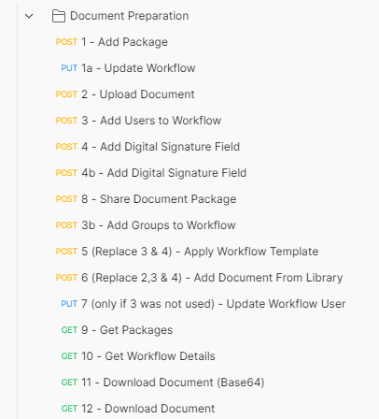

Document Signing (eSeal)
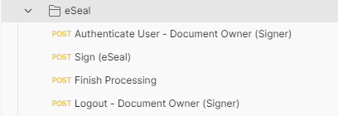

Webhooks
The system can create web hooks at configured URL for the following events:
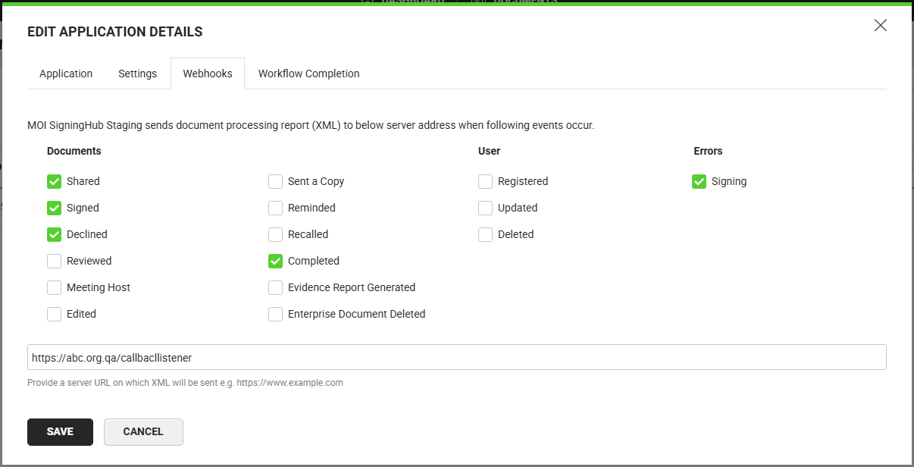
Webhook body would contain following XML:
Webhook listener can trigger different actions based on the type of current action performed. Following list contains possible values for action type:
- Documents
  - SHARED,
  - SIGNED,
  - DECLINED,
  - REVIEWED,
  - MEETING_HOST,
  - EDITED,
  - SENT_A_COPY,
  - REMINDED,
  - RECALLED,
  - COMPLETED,
  - EVIDENCE_REPORT_GENERATED,
  - ENTERPRISE_DOCUMENT_DELETED
- Users
  - REGISTERED,
  - UPDATED,
  - DELETED
- Error
  - SIGNING

2nd Factor Authentication using QDI
Client can invoke QDE WS Web Service which will send a push notification on user QDI Mobile Application. Following this notification user and see the authorization request after login. The user can accept or reject the request. The service will send this response back to client. Client will receive SUCCESS only if the user accept/approve the request. Depending on the response from the service the client can proceed with its use case.
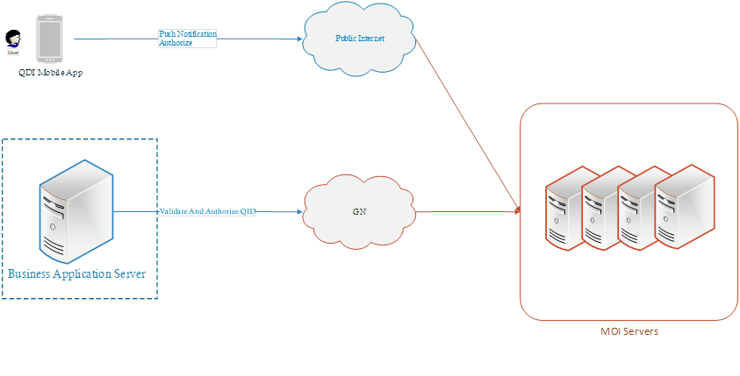
- Attached (QDEX-0.08.pdf) you can find the latest developers guide for the service
- A user (Citizen and Resident) is unable to login to QDI mobile application if user is:
  - Blacklisted
  - Restriction
  - Cancelled RP
  - Dead
  - ID Not Processed
In all of the above cased the service will return an error with specific error code and message. You can find details on response code in the attached developers guide (QDEX-0.08.pdf)
- Attached you can find XML request and responses:
  - ValidateAndAuthorizedQid - RequestResponses.xml
A success response would look like as below:
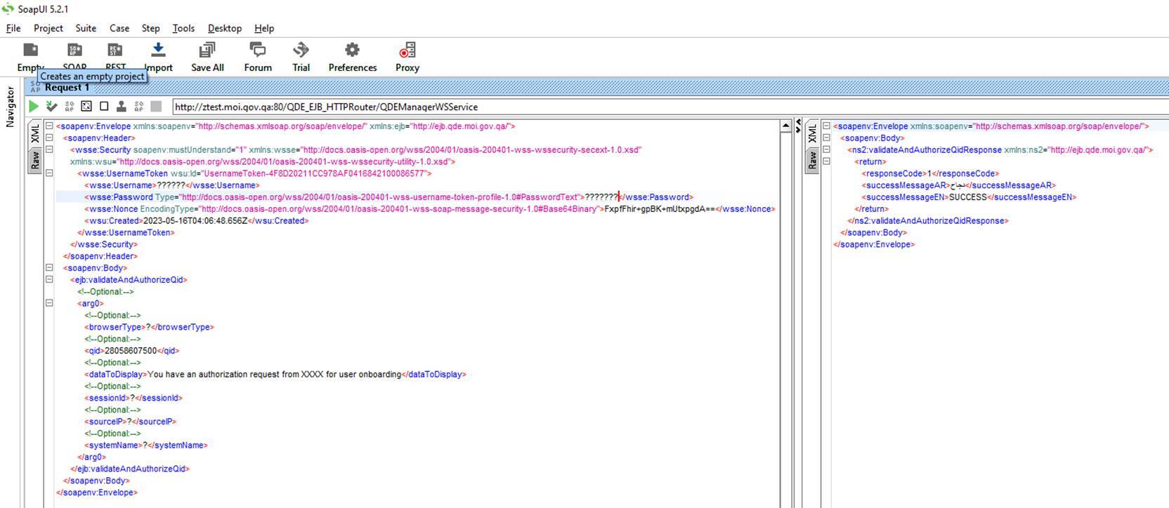
- For QDI Mobile Application in test/Staging environment kindly provide user Apple IDs and QIDs to clone their production data to test environment. It is mandatory to use the test applications by the users.

Make sure Firewall Rules must be implemented.

Remote Signing Service (RSS) Credentials
The following attributes should be configured in the ADSS Gateway Server of the external entity to establish the successful communication with MOI RSS.
Note that these attributes will be provided by the MOI Team.

Staging
Use the following attributes in the staging:
# | Item | Value | Comments
 | Client Name | Client Name* | Client name is used to identify the client
 | eSeal
- 1 | Client ID | *************** | A unique identifier for eSeal requests
 | Verification
- 4 | Client ID | *************** | A unique identifier for Verification requests
 | User Signing
 | API Client ID | *************** | A unique identifier for API requests
 | API Client Secret | ***************
 | Enterprise Admin
Table ‎5-1

Production
Use the following attributes in the production:
# | Item | Value | Comments
 | Client Name | Client Name* | Client name is used to identify the client
 | eSeal
- 1 | Client ID | *************** | A unique identifier for eSeal requests
 | Verification
- 4 | Client ID | *************** | A unique identifier for Verification requests
 | User Signing
 | API Client ID | *************** | A unique identifier for API requests
 | API Client Secret | ***************
 | Enterprise Admin
Table ‎5-2

* These values will be updated/provided by MOI separately.

Activity Logs
# | Date | Activity | Performed By

Appendix

Case Escalation
In case of any query, please contact below numbers.
- QDI Application
  - 942194 – 6am to 1pm
- Digital Signatures
  - 942443 – 6am to 1pm
  - rakbar@moi.gov.qa, mirfan@moi.gov.qa

